

.NET Core Fundamentals

Base of .NET Core

Yash Lathiya

|  |  |  |  |
| --- | --- | --- | --- |
| Sr No. | Topic | Date | Page No. |
|  |  |  |  |
| 1 | .Net Core Overiview |  |  |
| 2 | ASP.Net Core |  |  |
| 3 | Project Structure |  |  |
| 4 | wwwroot Folder |  |  |
| 5 | Program.cs |  |  |
| 6 | Startup.cs |  |  |
| 7 | launchSettings.json |  |  |
| 8 | appSettings.json |  |  |

Table of Contents

.NET Core Overview

* .NET core is upgraded streamline of .NET framework.
* .NET framework support only windows OS while .NET core is cross-platform technology, It supports mac, windows & linux.

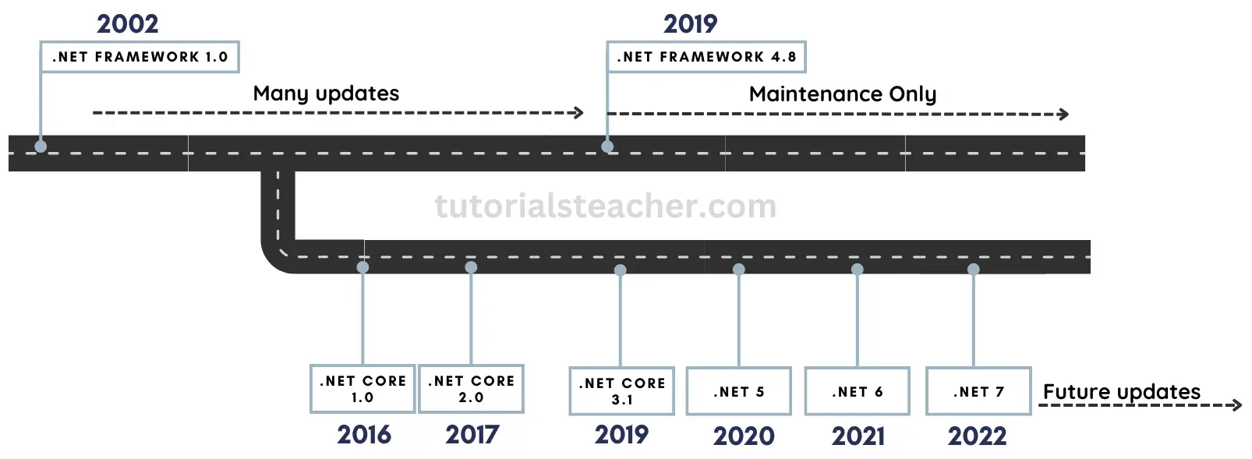

* Open Source
* Wide range of application
* Supports C#, F# & VB
* Includes CLI tools
* Supports flexible deployments (docker, user-wide & system-wide)
* High Performance
* Consistent over all architecture
* Modular Architecture

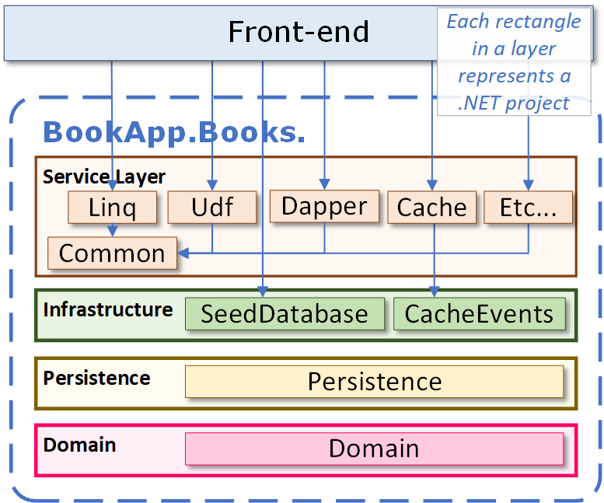

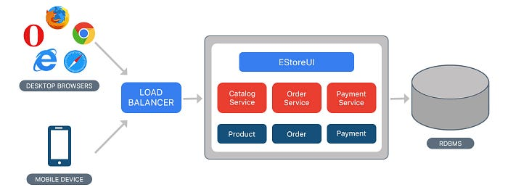[ Monolithic Architecture]  
[ mostly used for light-weight application]

[ Microservice Architecture ]  
[ mostly used for complexed application ]

[ Also needs inter service mechanism ]

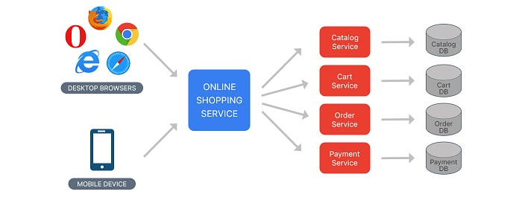

[ Modular Monolithic Architecture ]

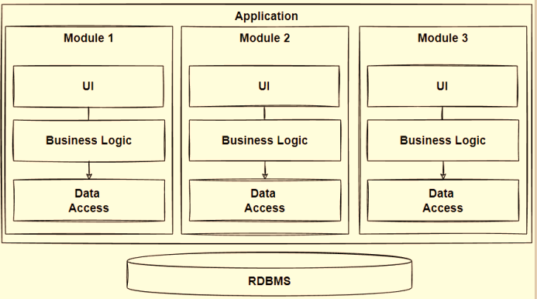

ASP .NET Core Overview

* ASP .NET is newly re-written from .NET framework,
* ASP .NET is for web application development.

Features

* Supports Multiple Platforms – OS
* Fast
* IoC Container (built-in container for automatic DI)
* Integration with modern UI Frameworks ( AngularJS, ReactJS)
* Code Sharing across versions
* Side-by-side app versioning
* Smaller deployment footprint ( size )
* Hosting

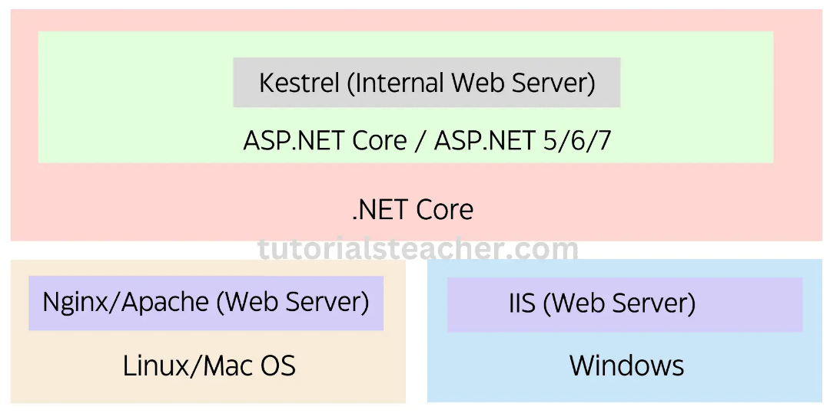

Project Structure

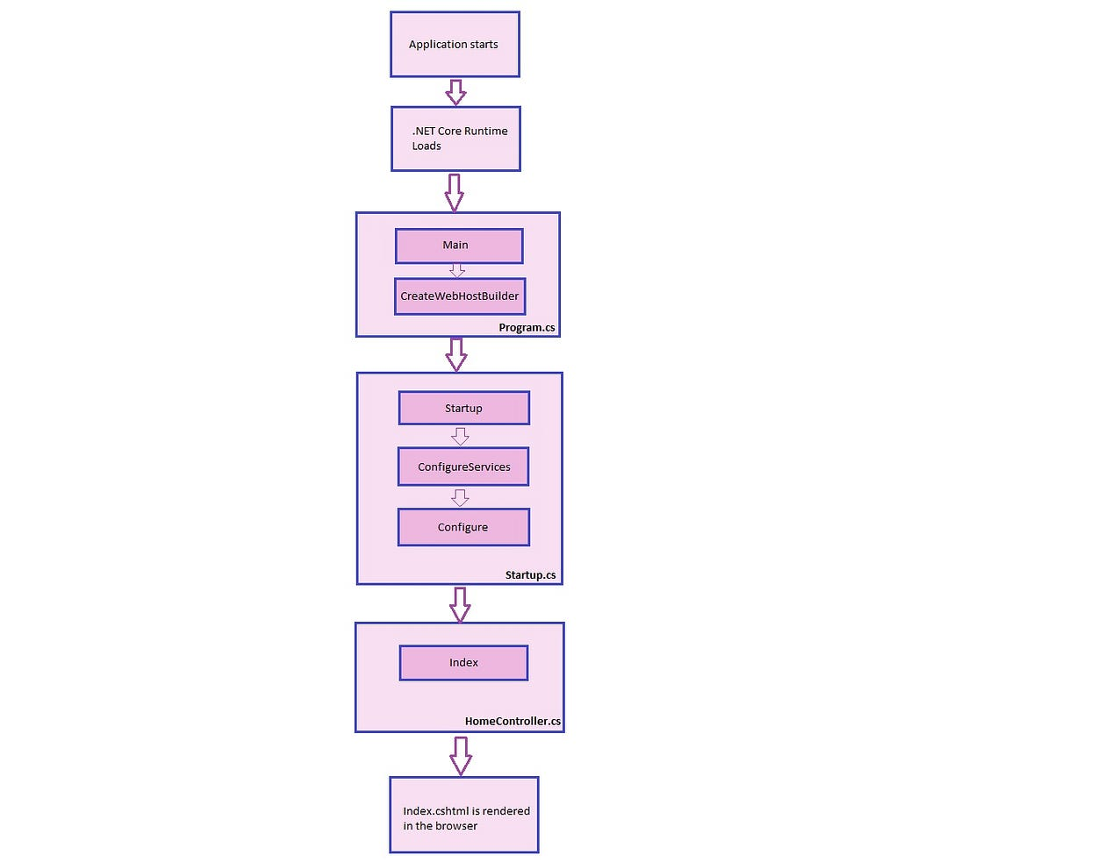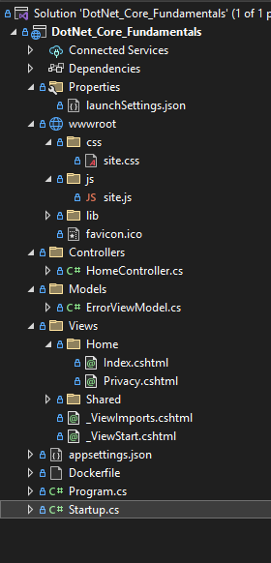

wwwroot Folder

* **Static Content Hosting**:

The wwwroot folder in ASP.NET Core serves as the hosting location for static web assets.

* **Direct Client Access**:

Files stored in wwwroot are directly accessible to clients via their URLs without any server-side processing.

* **File Types**:

Common static assets stored in wwwroot include HTML, CSS, JavaScript, images, fonts, and other files that don't require server-side computation.

* **No Processing Overhead**:

ASP.NET Core serves files from wwwroot efficiently, without any additional processing, improving performance and responsiveness.

* **Deployment**: During deployment, contents of the wwwroot folder are typically deployed to the web server or hosting environment to ensure availability to clients.
* **Organization**: Developers commonly organize static assets within subdirectories of wwwroot based on their type or purpose for better management and maintainability.
* **Efficient Content Delivery**: Using wwwroot allows for optimal content delivery, facilitating the building of modern web applications with ease.

**Program.cs**:

* Entry Point:

Program.cs is the entry point for an ASP.NET Core application.

* Main Method:

It contains the Main method, which is the starting point of the application.

* Host Builder:

Main method typically creates a host builder, configures the web host, and runs the application.

* Configuration:

It's responsible for configuring the application's startup and initializing necessary resources.

**Startup.cs**:

* Pipeline Configuration:

Startup.cs configures the application's request processing pipeline.

* ConfigureServices Method:

This method is used to set up services like dependency injection, logging, and configuration.

* Configure Method:

It defines how the application handles HTTP requests by adding middleware, setting up routing, and configuring authentication and authorization.

* Middleware Configuration:

It's where you define middleware components to process HTTP requests and responses.

**launchSettings.json**:

* Debugging Configuration:

launchSettings.json defines settings for launching and debugging an ASP.NET Core application.

* Profiles:

It contains profiles with configurations for different environments such as development, staging, and production.

* Application URL:

Profiles specify properties like the application URL, environment variables, and command-line arguments used during debugging.

* Customization:

Developers can customize how the application runs locally during development using this file.

**appSettings.json**:

* Configuration Storage:

appSettings.json is used to store application settings in key-value pairs.

* Application Settings:

It contains settings that configure the behavior of the application such as database connection strings, logging settings, and feature toggles.

* IConfiguration:

Settings defined in appSettings.json can be accessed programmatically throughout the application using the IConfiguration interface.